**Experiment No:** 01.

**Experiment Name:**

1. Find out the root of f(x) = xex – 1,start with the interval [0 1] and error=5% using Bisection method.
2. Find out the root of f(x) = xex – 1,start with the interval [0 1] and error=5% using False Position method.
3. Find out the root of f(x) = e-x – x,where x0=0 using Newton Rapshon method.
4. Find out the root of f(x) = e-x – x, using Secant method.

**Objective:**

In this lab,we can learn how to find out the root of an equation using Bisection method,False Position method,Newton Rapshon method.

**Problem Code:**

i)Bisection Method

xl=input('Lower value :');

xu=input('Upper value :');

Error=input('Give the Error Rate : ');

for k=1:1:100

xr(k)=(xl+xu)/2 ;

Fxl =xl*exp(xl)-1;

Fxr =xr(k)*exp(xr(k))-1;

if(Fxl*Fxr<0)

xu=xr(k);

else

xl=xr(k);

end

if(k>1)

err= abs(((xr(k)-xr(k-1))/xr(k))*100);

end

if(k>1)

if(err<=Error)

break;

end

end

end

fprintf('The Root is =%f \n',xr(k))

fprintf('The Error Rate =%f\n',err)

fprintf('Number Of Step =%d\n',k)

**Output:**

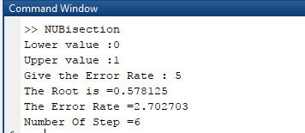

**Problem Code:**

ii)False Position Method

%False Position Method%

xl=input('Lower value :');

xu=input('Upper value :');

Error=2;

for k=1:1:100

fxl =xl*exp(xl)-1;

fxu =xu*exp(xu)-1;

xr(k)=(fxu*xl-fxl*xu)/(fxu-fxl);

if(fxl*fxu<0)

xu=xr(k);

else

xl=xr(k);

end

if(k>1)

err= abs(((xr(k)-xr(k-1))/xr(k))*100);

end

if(k>1)

if(err<=Error)

break;

end

end

end

fprintf('The Root is =%f \n',xr(k))

fprintf('The Error Rate =%f\n',err)

fprintf('Number Of Step =%d\n',k)

**Output:**

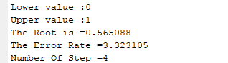

**Problem Code:**

iii)Newton Rapshon Method

%NewTon Raphsan Model

Error=input('Error Rate : ');

xi=0;

for i=1:1:100

fx=exp(-xi)-xi;

dx=-exp(-xi)-1;

x1=xi- (fx/dx) ;

err=abs(((x1-xi)/x1)*100);

if(err<=Error)

break;

end

xi=x1;

end

fprintf('The Root is = %f\n',x1);

fprintf('The Error is = %f\n',err);

fprintf('Number of step = %d\n',i);

**Output:**

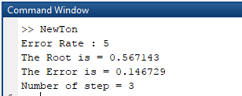

**Problem Code:**

iv)Secant Method

clc;

close all;

clear all;

xl=0;

xu=1;

er=input('Enter an error: ');

for i=1:1:100

y1=exp(-xl)-xl;

y2=exp(-xu)-xu;

xr(i)=(((y2*xl)-(y1*xu))/(y2-y1));

error=abs((xr(i)-xu)/xr(i))*100;

xl=xu;

xu=xr(i);

if(error<=er)

break;

end

end

error

fprintf('The root is : %f ',xu);

**Output:**

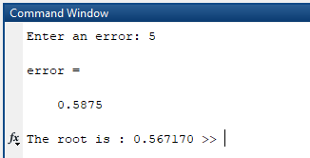

**Discussion:**

From this lab we learnt about the different process of finding root of given equation.In this lab our methods are Bisection Method,False Position Method , Newton Raphsan Method & Secant Method.Bisection & False Position method are called Bounded Method as they are bounded by upper and lower limit.Newton Raphsan Method is called Open method as it is not bounded.From The ouput ,we can see that The Bisection Method is slower than any other method.It takes 6 step whereas false position method takes 4 step to find the root.Among these ,Newton Raphsan method is more effective method as it takes less step and error rate is quite lower than any other method.